**Lab 2: PID Control**

You are given three Python programs:

1) “PIDControl Straightline Twiddle.py” is the Python program from Udacity course Lesson 15: PID Control, “21. Parameter Optimization (solution)”. It considers a straight-line reference trajectory, using function twiddle() to automatically tune controller PID gains, incl. params[0] (Proportional), params[1] (Derivative) and params[2] (Integral):

2) “PIDControl Racetrack.py” is based on the Python program from Lesson 16: Problem Set 5, “4. Quiz: Racetrack control”. It considers a circular clockwise reference trajectory, with start position at (0,25).

(Please watch Lesson 15 PID Control, AI for Robotics at Udacity, incl. [Twiddle](https://learn.udacity.com/courses/cs373/lessons/91f48b5b-a063-41f9-ace6-5fb9e7508941/concepts/b740218e-b0eb-40dc-80af-343912305293), [Parameter Optimization](https://learn.udacity.com/courses/cs373/lessons/91f48b5b-a063-41f9-ace6-5fb9e7508941/concepts/eda69fab-ea68-4ceb-ab5d-52c447930c9e), [Parameter Optimization (solution)](https://learn.udacity.com/courses/cs373/lessons/91f48b5b-a063-41f9-ace6-5fb9e7508941/concepts/e4f0ba1d-a5a0-42e1-bcf2-0ca74aabbf85).

As the links are specific to each user login, please use my Udacity account: Username: [zgu666@yahoo.com](mailto:zgu666@yahoo.com), Password: autonomafordon)

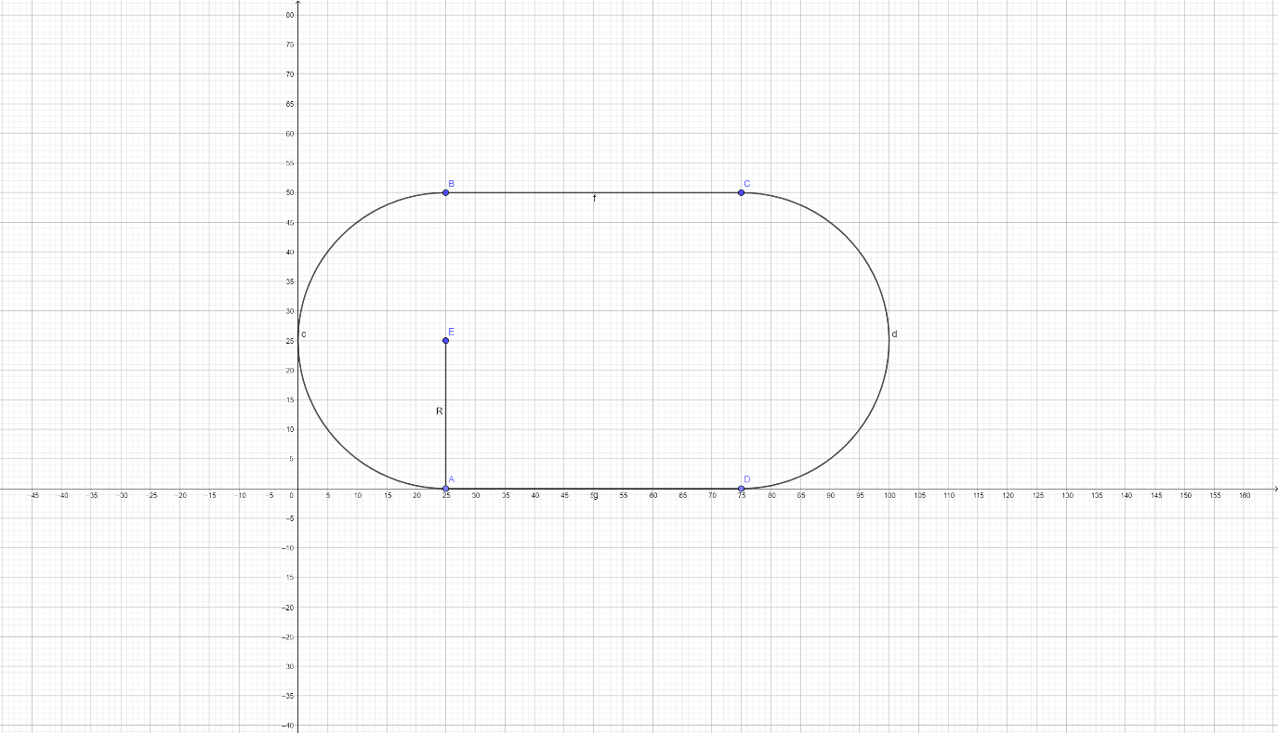

3) “PIDControl Racetrack Twiddle.py” adds the function twiddle() to PIDControl Racetrack.py to tune controller PID gains params[] automatically.

**Task 1**: (The first two programs are for your reference only.) Start from PIDControl Racetrack Twiddle.py, change the track shape to a round circle with radius 50 (so you need to modify the function cte() for computing cross-track error), and modify twiddle() to tune:

1. P controller, with $K_{i}=K_{d}=0$;
2. PI controller, with $K_{d}=0$;
3. PD controller, with $K_{i}=0$;
4. PID controller.

**Task 2**:The car speed is set to 1.0 in the original program. Setting a higher speed may cause the car to lose control, as shown in the following visualization of the actual trajectory for speed of 10.0, obtained with plt.plot() (you may or may not get the exact same result).

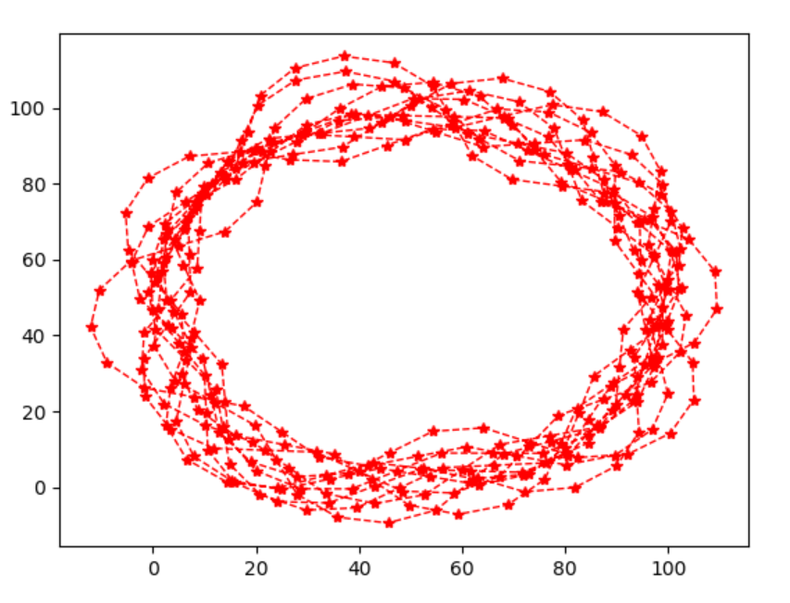

To keep control, one can either increase track length by increasing circle radius, or reduce timestep size dt (increase sampling rate). Let’s take the latter approach. (Refer to L6 Control, p. 34 “For General 𝑑𝑡” for how to add the variable 𝑑𝑡.) Tune a PID controller with twiddle() for speed=10.0. Try different timestep sizes dt until you achieve low tracking error. (A good heuristic is to reduce dt proportional to the increasing speed, to keep the distance traveled in each timestep constant.)

(The total number of simulation timesteps is 2N. We compute the average error and record the trajectory for the last N timesteps, in order to skip initial transient dynamics in the first N timesteps and focus on the steady state performance. We suggest setting N=1000 to traverse the track multiple cycles.)

# Submit a report and corresponding Python programs to Canvas:

**For Task 1:**

For each of the 4 controllers (P, PI, PD, PID) with default speed 1.0:

1. The final controller PID gains and average error.

2. Visualization of actual trajectory for the last N timesteps.

3. Python programs named “PControl Racetrack-YourLastName.py”, “PIControl Racetrack-YourLastName.py”, “PDControl Racetrack-YourLastName.py”, “PIDControl Racetrack-YourLastName.py”,

**For Task 2:**

For PID controller with speed 10.0, and for (a) timestep 1.0, (b) your final dt that achieves low tracking error:

1. The final controller PID gains and average error.

2. Visualization of actual trajectory for the last N timesteps.

3. Python programs named “PIDControl Racetrack-TS1-YourLastName.py”, “PIDControl Racetrack-TSdt-YourLastName.py”.

**Programming Tips**:

One way of implementing the P, PD, PI control is by initializing the array dp as follows:

PID: dp = [1.0, 1.0, 1.0]

PD: dp = [1.0, 1.0, 0]

P: dp = [1.0, 0, 0]

P: dp = [1.0, 0, 1.0]

Another way is to initialize array p to 0:

p = [0.0, 0.0, 0.0]

then use different loop indices when updating array p:

PID: for i in range(len(p))

PD: for i in range(len(p)-1)

P: for i in range(len(p)-2)

PI: for i in range(len(p))

if i==1 continue